**Arjan de Bruijn**

Fort Collins, Colorado

Resume

Summary of Qualifications

* More than 8 years of experience in software development and GIS
* Fluent in most coding languages (see skills page for details)
* Developer of efficient code
* Technical writing such as software documentation
* Hard-working
* Authorized to work in the USA

# Professional Background

My career path has centered on forestry and land use modeling, incorporating biogeochemistry, statistics, and development of simulation software. I have been working in academia for almost a decade and would like to move to the private sector. I specialize in developing geospatial software applications. Non-technical skills include giving presentations, fluency in English, German, and Dutch, and working within large, widely dispersed development teams.

***Graphics: geospatial model of gypsy moth outbreak in Maryland (above);***

***simulation of forest tent caterpillar population dynamics in northern Minnesota (below)***

## Software and Programming Languages

http://localhost:57770/images/ProgramIcons/matrix.pngManaging large amounts of data and without processing bottlenecks has been an important element of my work. Typically the simulation models I use are two dimensional (i.e. they read and write maps). Calculating simulation outputs for each of the pixels, often implementing multiple processes per pixel, easily becomes a very time consuming operation, so I have developed a number of techniques to optimize my code.

More than 8 years of experience. I am still primarily using Visual Studio 2010 because of budgetary constraints, but I have also tried more recent versions of Visual Studio Express.

More than 3 years of experience. The LANDIS user interface I describe on my Portfolio page was developed in C#.

More than 3 years of experience developing code for my PhD.

I worked on an ArcGIS plugin written in VB for approximately 1 year.

More than 8 years of experience with software versioning through TortoiseSVN.

8 years of periodic use of R for statistics, plotting graphs with simulation output, and running code that colleagues sent me.

I have used Python for data management, to reorganize data in large .txt files, e.g. tweaking data processing scripts from colleagues.

Approximately 8 years of occasional use for statistical analysis. Ran simulation models that colleagues developed in MatLab to see how they worked. Made small changes to models.

Approximately 4 years of experience writing and tweaking Inno Setup file protocols.

I worked for 1 year on a simulation model that was designed as a plugin for ArcGIS. For the past 3 years at Purdue University, I have used ArcGIS to make a lot of maps.

I use Microsoft Office Suite products like Word, Excel, PowerPoint, and Access on a daily basis.

I used SQL statements to store data in the ArcGIS plugin I worked on for 1 year.

One of the simulation programs I worked on at ALTERRA in the Netherlands uses a Firebird database.

I developed this website using HTML5.

I used CSS for the styling of this website.

I used JavaScript for interactive elements in this website.

## Deforestation in Indonesia

For my master's project at Wageningen University, I used land use derived from aerial photographs of eastern Borneo taken in [2000](http://localhost:57770/Portfolio.aspx) and [2009](http://localhost:57770/Portfolio.aspx) to evaluate hypotheses about patterns of land use changes and to predict future land use, for example:   
  
1. There is no spatial correlation between land use transitions.  
2. Land use transitions occur near human settlements.  
3. Land use transitions occur near water.

Given the following land use transition rates for the period of 2000-2009:

|  |  |  |  |  |
| --- | --- | --- | --- | --- |
| **From / To** | **Forest** | **Secondary Forest** | **Cropland** | **Settlements** |
| **Forest** | 0.998 | 0.002 | 0 | 0.0003 |
| **Secondary Forest** | 0 | 0.995 | 0.005 | 0 |
| **Cropland** | 0 | 0 | 0.99 | 0.01 |
| **Settlements** | 0 | 0 | 0 | 1 |

you can predict what the future landscape will look like. I programmed a simple simulation algorithm that predicts future land use in the code of this website. You can try it by selecting one of the three hypotheses and/or changing the transition rates in the table and clicking the “Simulate 9 years” button.

## Landis User Interface

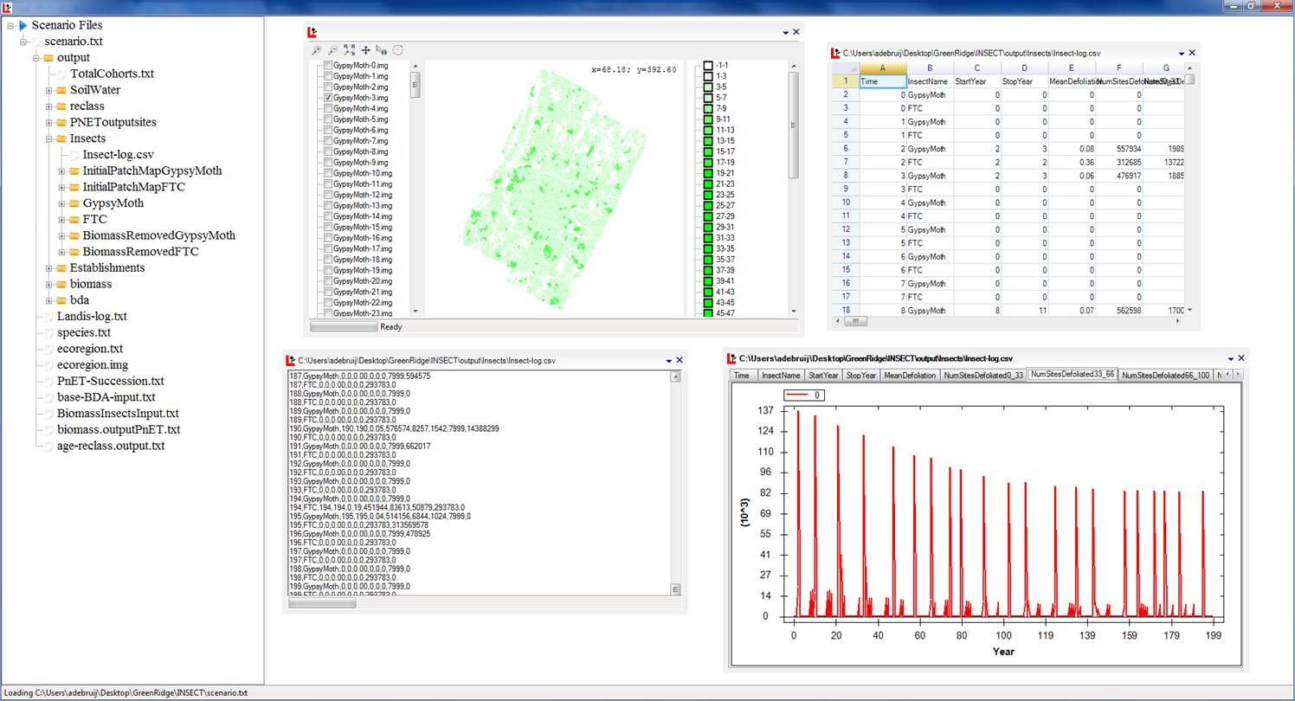

The [LANDIS](http://www.landis-ii.org/)-II Forest Landscape Simulation Model lacked a user-friendly interface to facilitate analyses, so I developed one. It is a Windows Forms application written in C# developed in .NET 3.5. The interface consists of a file tree (on the left) where you add a LANDIS scenario file, a simple ASCII file in which other input files and some settings for the model are specified. When you add a scenario, the program will read that file and check for any pathnames in that file (i.e. other input files) and adds those to the file tree. Additionally, the user can start a simulation and the user interface will periodically check whether there are new output files which it will add to the file tree as well. The work space is simply a surface where you can display one or many dockable screens (using [a Visual Studio IDE like Dock Container](http://www.codeproject.com/Articles/25976/Visual-Studio-IDE-like-Dock-Container)). Input and output files in the file tree can be displayed in the following formats:

* maps based on the freeware [MapWinGIS](http://mapwingis.codeplex.com/)
* graphs using the free software called [ZedGraph](http://sourceforge.net/projects/zedgraph/)
* spreadsheets that use [a Free .NET Spreadsheet Control](http://www.codeproject.com/Articles/691749/Free-NET-Spreadsheet-Control)
* text editor by dragging the file from the file tree and dropping it in the work space.

The new LANDIS user interface is currently used in LANDIS instructional workshops and by many individual LANDIS users.

## Bayesian Calibration

Bayesian calibration is a method to map model probability given a set of observations. It has been used in disciplines as diverse as medicine, law, and internet search engines. I used it to estimate the rate of wood decomposition. If you call the decomposition rate 'b' in percent per year, you can use an algorithm called a Markov Chain to reiteratively select semi-random values for 'b', calculate remaining biomass for a stretch of time, and calculate a score that represents how likely the decomposition rate 'b' is, given the set of measurements.

This is what you see at work in this graph: each red line is a decomposition trajectory for a single value of 'b'. There is a tweak in a Markov Chain that assures that decomposition rates that score well (i.e. the model compares well with actual measurements) are selected more frequently. It takes a while for the Markov Chain to find this 'hotspot' of high model scores, but after ~100 iterations, the average 'b' of the iterations in the graphs becomes pretty stable at around 7%. So my best estimate of the decomposition rate of the tree logs is 7% per year. The black graph on my home page demonstrates a similar algorithm applied to measured areas of forest defoliation in Northern Minnesota, compare to a model complicated simulation model.

## RELEVANT EXPERIENCE

## Purdue University - West-Lafayette, IN - 2011 to present

### Responsibilities

I developed simulations to predict the fate of reintroduced American chestnut trees in the Appalachians. By the mid-1900s, American chestnut was wiped out by a blight that was imported from Japan in the early 1900s. Asian chestnuts are largely resistant, and recent cross breeds (genetically 94% American and 6% Asian) share blight resistance, therefore are candidates for reintroduction. However, the Appalachians have changed over the last 100 years due to insect plagues and changes in land management and climate. I am combining information from lab and field trials with landscape information to predict how the new blight-resistant breed would fare upon its reintroduction in the Appalachians.

### Accomplishments

* Developed a module, PnET-Succession, for the [LANDIS](http://www.landis-ii.org/)-II Forest Landscape Simulation Model simulation platform that better incorporates interactions between climate change and competition for light and water between trees. LANDIS is Windows software developed in C#. This required extensive use of C#, Visual Studio 2010, 2013, R and some Python. PnET-Succession is currently used in several universities and the Food and Agricultural Organisation (FAO) of the United Nations.
* PnET-Succession comes with an installation file I developed in [INNO](http://www.jrsoftware.org/isinfo.php), so I am experienced in the issues that come with transplanting software to other computers.
* Wrote comprehensive technical documentation that I have kept up to date during the development process.
* Additionally I developed a user interface (see [Portfolio](http://localhost:57770/Portfolio.aspx)) as a Windows Forms application. The user interface uses threading and BackgroundWorkers to load maps and data.

### Publications

* Decomposition rates of American chestnut (*Castanea dentata*) wood and implications for coarse woody debris pools

[(Canadian Journal of Forest Research)](http://www.nrcresearchpress.com/doi/abs/10.1139/cjfr-2014-0270" \l ".VUlrpvlVhBc)

* Integrating ecophysiology and forest landscape models to improve projections of drought effects under climate change

[(Global Change Biology)](http://onlinelibrary.wiley.com/doi/10.1111/gcb.12713/abstract)

* Toward more robust projections of forest landscape dynamics under novel environmental conditions: Embedding PnET within LANDIS-II

[(Ecological Modeling)](http://www.sciencedirect.com/science/article/pii/S0304380014002415)

## Agroscope Reckenholz Taenikon - Zürich, Switzerland - 2010 to 2011

### Responsibilities

I developed simulations to evaluate how differences in soil carbon in grasslands relate to management intensity. Carbon is the main constituent of dead organic matter, for example plants or harvest residues. High carbon concentrations in arable lands are good for soil fertility, water retention and mitigation of climate change. Here I evaluated how soil carbon concentrations depend on management activity and intensity.

### Accomplishments

Developed a 1D simulation model to simulate biomass and carbon dynamics in lowland grasslands. The simulation model was developed in C++ and came with a simple Windows Forms based user interface.

### Publications

* Differential long-term effects of climate change and management on stocks and distribution of soil organic carbon in productive grasslands

[(Biogeosciences)](http://www.biogeosciences.net/9/1997/2012/bg-9-1997-2012.html)

## Alterra B.V. – Wageningen, Netherlands - 2009 to 2010

### Responsibilities

Debugged and improved simulation programs such as the Landscape ecological Analysis and Rules for the Configuration of Habitat (LARCH) model.

### Accomplishments

* Improved the LARCH model user interface which is a plug-in for ArcMap to analyze population viability given fragmented habitat.
* Expanded functionality of the metapopulation simulation model (METAPHOR) interface which operates as a standalone Windows program that uses GIS freeware to embed GIS capabilities into the program interface.

## IMK-IFU - Garmisch-Partenkirchen, Germany - 2006 to 2009

### Responsibilities

I supported the development of a biogeochemical simulation platform "MoBiLE". MoBiLE is a modular platform for biogeochemical simulations where the modules are responsible for particular biogeochemical properties. I developed a module for the microbial biomass component.

### Accomplishments

Developed a 1D model subroutine DECONIT that was published as an isolated program and later embedded in the larger modelling platform MoBiLE.

### Publications

* An alternative modelling approach to predict emissions of N2O and NO from forest soils

[(European Journal of Forest Research)](http://link.springer.com/article/10.1007%2Fs10342-010-0468-y" \l "page-1)

* Linking carbon and nitrogen mineralization with microbial responses to substrate availability — the DECONIT model

[(Plant and Soil)](http://link.springer.com/article/10.1007%2Fs11104-009-0108-9)

* Model evaluation of different mechanisms driving freeze-thaw N2O emissions

[(Agriculture Ecosystems & Environment)](http://www.sciencedirect.com/science/article/pii/S0167880909001340)

## EDUCATION

## PhD in Forest and Environmental Sciences, *Magna Cum Laude*. Albert Ludwigs University – Freiburg, Germany, 2009.

## M.A. in Philosophy of Science. Amsterdam University – Amsterdam, Netherlands, 2005.

## Wageningen University – Wageningen, Netherlands, 2005.